PROJECT PROPOSAL

NIHVA TECHNOLOGIES PVT. LTD.
187, G-Block, Thermax chowk, Above Renault Showroom, MIDC
Chinchwad, Pune – 411019.

Customer name | Hettich India Pvt Ltd
Office address | 302, Durolite House Opp SAB TV, Near Link Road  Mumbai -400053
Project location | Mumbai
Contact person name | Mr. R K Singh
Email id | RK_Singh@in.hettich.com
Contact number | 96889 66960

Contact Person: Mr. Mayur Derle
Mob No.: 7709209333
Email id: automation@nihva.com
Web: http://www.nihva.com

AUTOMATION SOLUTION-DIVISION

Title: Packaging Line & Assembly

Description :

Components like Hinges, MP & Pouches will be fed to Feed Conveyor.

- Box opener opens folded boxes and tapes their base and stacks them vertically in 10s and 20s.These boxes will be conveyed to points 1-12 by a trolley.

- All three types of product categories (Hinges, MP and Pouches) will get filled in corresponding boxes-in required numbers. These boxes will be placed manually on the feed conveyors.

- After filling the box is pushed into main conveyor. Empty box will roll into the vacant space created.

- In this main conveyor, the boxes travel to the end and takes a u turn and gets taped in auto taper.

- After taping, boxes are diverted into 2 appropriate side conveyors. This will happen after box is scanned for height.

- In first side conveyor (for Hinges and MP), taped boxes are stacked by an operator on a pallet and strapped manually by a hand Strapper- after placing a cap on them.

- In the second conveyor (for pouches), the boxes will strapped automatically by a strapping machine located in it and will be stacked by operator on a pallet.

Date: 06/02/2018
Dear Sir,

Thank you for giving us an opportunity to participate with our offer on the above project. We enclose here with our proposal includes:

List of Equipment’s:

Sr No. | Machines | Qty | Unit
1 | Box Opener Machine | 1 | Nos
2 | Pouching Machine | 1 | Nos
3 | Bowl/Linear Feeder | 1 | Nos
4 | Feed Conveyor | 5 | Nos
5 | Box pushers | 5 | Nos
6 | Main Conveyor 1 | 1 | Meters
7 | Main Conveyor 2 | 1 | Meters
8 | MP Conveyor | 1 | Meters
9 | Strapping Line Conveyor | 1 | Meters
10 | Taping machine | 3 | Nos
11 | Strapping machine | 1 | Nos
12 | Hand strapper | 2 | Nos

Box Opener Machine:

- It will take flat boxes and open it and tape it at base.

- It will stack boxes at one output.

- Capacity: 35 boxes/min Maximum

- Open boxes will have stacked vertically by the machine.

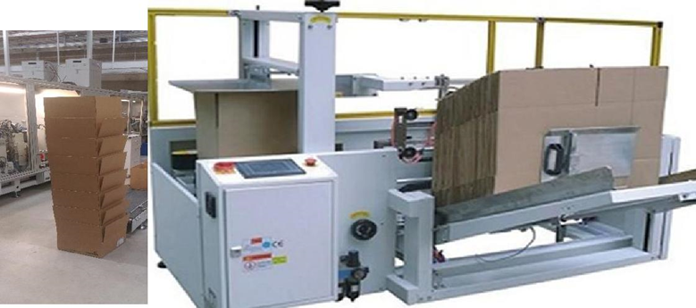

Pouching Machine:

- Sealed Pouches will fall inside a box located on a conveyor adjacent to machine.

- Machine will have counting facility, with a visible LCD screen.

- Machine will have stopped after programmed quantity is filled.

- Machine is with hooter & indication alarm.

- Pouching Line Consist of 4 no’s of Bowl feeders, 4 nos of linear feeder, pouching machine, conveyor, HMI & Counter system.

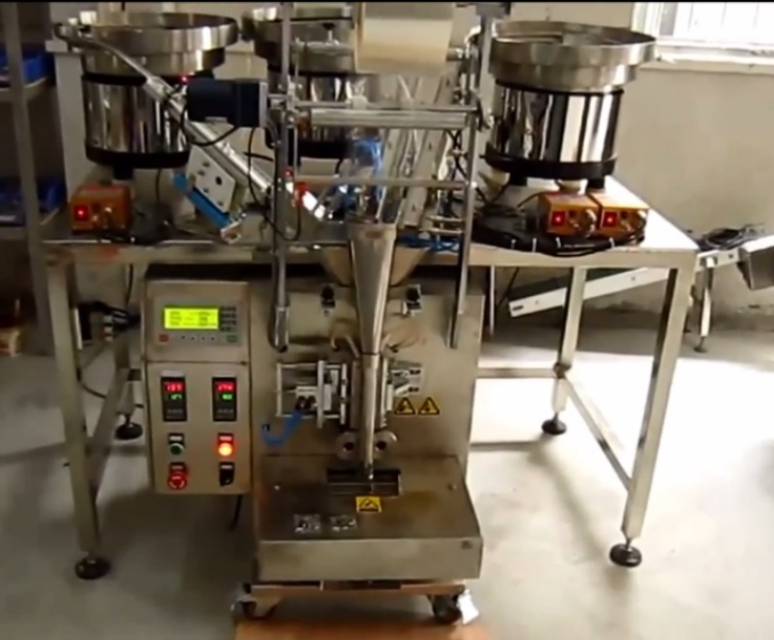

Linear Feeders:

Linear feeder will be use to feed MP components in a bin/box.

Linear feeder will be with Indicators, sensors & HMIS.

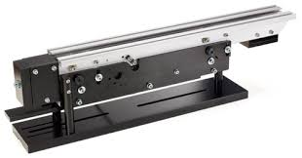

Bowl Feeder :

Vibratory bowl feeders are common devices used to feed individual component parts for assembly on industrial production lines. They are used when a randomly sorted bulk package of small components must be fed into another machine one-by-one, oriented in a particular direction.

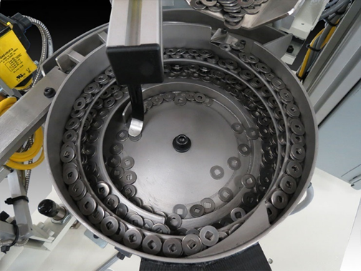

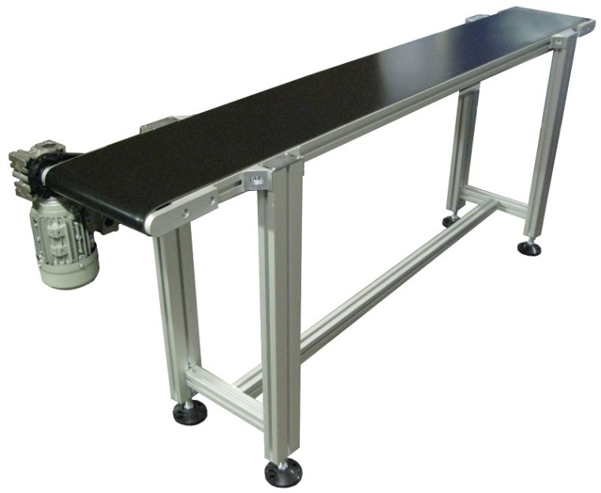
Feed Conveyors:

Motorized conveyor.

Conveyor Width 0.6 meter

Conveyor Length: 2.5 meter each.

Conveyor type: Belt conveyor.

It will have sensing mechanism at the collecting point.

It will read and control the output of the product- Hinges, pouches or Mounting plates.

It will stop the line when required number is filled in the box.

It will push the filled box to the main conveyor- through pusher/ other mechanism.

- Box Pushers

Pushers will transfer boxes from one conveyor to other.

Pusher will consist of cylinder, sensors & connections.

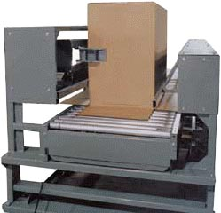

Main Conveyor 1 & 2 :

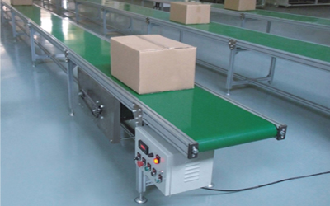

Auto operation.

Conveyors Width: 0.6 meter

Modular Belt Conveyor.

Length of Conveyor 1: 40 meters

Length of Conveyor 2: 25 meters

It will have sensing mechanism at various point.

MP Conveyors:

Auto operation.

Conveyors Width: 0.6 meter

Belt Conveyor.

Length of Conveyor: 22.5 meter

It will have sensing mechanism at various point

- Strapping Line Conveyor:

Auto operation.

Conveyors Width: 0.6 meter

Belt Conveyor.

Length of Conveyor: 2 meters

It will have sensing mechanism at various point

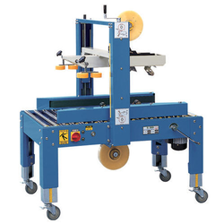
10.Auto Taping Machine:

Automatic Taping operation.

It will read the approaching box.

The machine will shake to box to level it.

The machine will hold down a plate to level the top

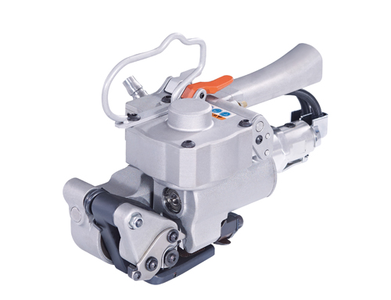
11. Hand Strapper:

This machine is located between side conveyors.

It is pneumatically operated.

Joining: Friction welding on PP or PET strap

- Techno – Commercial Offer

Sr No. | Description |  | Qty | Unit | Rate In INR | Net Amount in INR
1 | Box Opener Machine |  | 1 | Nos | 11,50,000 | 11,50,000
2 | Pouching Machines |  | 1 | Nos | 8,50,000 | 8,50,000
3 | Linear Feeders |  | 1 | Nos | 1,50,000 | 1,50,000
4 | Bowl Feeder |  | 1 | Nos | 1,50,000 | 1,50,000
5 | Feed Conveyors |  | 5 | Nos | 1,00,000 | 5,00,000
6 | Box Pushers |  | 5 | Nos | 22,000 | 1,10,000
7 | Main Conveyor 1 |  | 1 | Nos | 8,50,000 | 8,50,000
8 | Main Conveyor 2 |  | 1 | Nos | 5,00,000 | 5,00,000
9 | MP Conveyor |  | 1 | Nos | 4,27,000 | 4,27,000
10 | Strapping Line Conveyor with online Strapping machine |  | 1 | Nos | 2,50,000 | 2,50,000
11 | Auto Taping Machine |  | 1 | Nos | 1,44,000 | 1,44,000
12 | Hand Strapper |  | 2 | Nos | 1,21,000 | 2,42,000
-
Total Cost Of Project |  |  |  | 53,23,000
 |  |  |  | Amount In Words
GST PUNE : |  | 27AAECN0437H1ZM |  | Rupees Fifty-Three Lacs Twenty-Three Thousand Only

E. Drawings Training and warranty

Drawing:

We will issue a full set of drawings for approval within 2 weeks of receiving the confirmed order and finalized design details.

Training:

After installation of the Conveyor system, we will train the Clients personnel in the operation and basic maintenance, including the understanding of the error codes on the control system (if applicable).

Warranty:

- The warranty period is twelve months from the date of installation and commissioning.
- If a defect arises within the warranty period stated, which is attributable to faulty design,
- materials or installation workmanship the product will be repaired at our discretion without
- charge. This guarantee is subject to proper use of the product and assumes that the product is
- regularly serviced and maintained by skilled personnel in accordance with the operation and maintenance instructions supplied.

Maintenance & Service Agreement:

We would suggest that you take advantage of a maintenance and service agreement on the NIHVA products, which will guarantee trouble free operation and speed of response in an emergency. Customized proposals are available on request.

We are pleased to inform that we also undertake AMC for all of our

products & for any of your existing facilities.

Maintenance and service aren’t about what you get. They’re about what

you avoid: failures, losses and unplanned interruptions.

Client Scope:

- All Structural support is in client scope.

- Civil work/machineries/structural work required to support are in client scope.

- Unloading from Truck Placement on site.

G. Terms and Conditions: -

- Price : Ex. Works Pune

- P & F : 3 % Extra at the time of delivery.

- Freight Notes : Extra as applicable.

- Delivery : Within 9- 10 weeks from date of receipt of
confirmed purchase order, advance payment,
drawing approval.

- Payment Terms : 80% advance along with confirmed purchase
order balance before dispatch.

- Insurance : Extra as applicable.

- GST : Extra as Applicable on total supply value.

- Validity : 15 days from date of quotation.

9.Warranty : 12 months from date of supply.

Please feel free to contact Mr. Mayur Derle on 7709209333 for any further clarification in this concern.

With Best Regards,
Pooja Badre
7709209333
For NIHVA Technologies Pvt Ltd

